Creating an AI Virtual Assistant

*Labs 1 and 2*

# Preface

## Industry Use-case: Build a Chatbot for a Restaurant

While chatbots offer many benefits, the most significant of them are listed below:

* Book tables and orders, even before the customer has reached the restaurant.
* Customers can track the status of their orders.
* Serve any number of customers 24/7
* Personalized marketing
* Customer analytics
* Does the job of many employees and avoids employees training cost?
* Integrate chatbot to social media and make use of vast social media user base
* Increases brand engagement
* Businesses can stay in direct contact with the customers, which will enable to stop unnecessary revenue share with services delivery mediums, such as Postmates.

Chatbots help in dealing with the challenges faced by the restaurant industry with analytics, as well. Chatbots can help management gather and organize sales data, then strategize their marketing efforts based on location and customer interests. This helps management to deliver personalized marketing plans, push notifications (about loyalty programs or new items) and personalized dining experiences to the customers. This instills a feeling of community with the customers, which ultimately helps the management retain customers as well as increase their satisfaction.

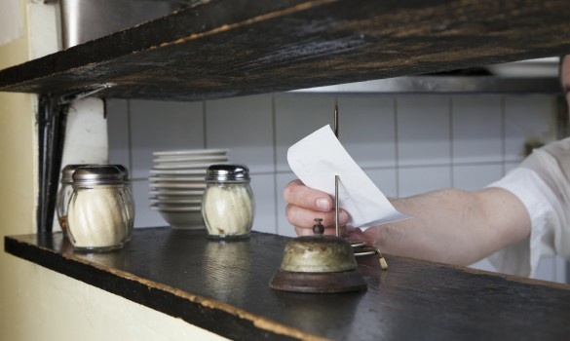

Let’s disrupt the traditional way of ordering food with Watson Assistant.

<https://businessfirstfamily.com/pick-restaurant-online-ordering-software/>

## Overview

Chatbots make software accessible to everyone who understands human language. A customer can avoid the frustration that comes with having to memorize and navigate complex menus and button layouts that are always changing with software updates. Instead, computers can be operated with simple human language that people can understand. Customers can now simply ask a bot to take them where they want to go, or to enable a feature without having to hunt it down. Good bot services encourage users to engage more deeply with software features that might otherwise go unnoticed, because they provide a richer, more natural experience. For example, imagine an image editing suite that can respond to a command like: “Make the background of my photo darker.”

In addition to enhancing the customer experience, chatbots free up agents to respond to the more complex problems that are better solved by a customer service agent. When people are able to delegate a portion of their workload onto a conversational bot, they are now able to participate in higher value decision making for the company and expand their skills, which benefits the company and enriches the agents.

The Royal Bank of Scotland used Watson to build their bot framework, which consists of two bots called “Cora” and “Marge.” Cora handles simpler, “first-time” problem resolution, and Marge assists the agents themselves when they need more information to respond to a customer’s query.

Click the link below and scroll to the bottom of the page. There is an imbedded chatbot with various skills that you can play with. Try it:

<https://www.ibm.com/watson/how-to-build-a-chatbot>

**Estimated Time to Complete:** 1 Hour

## Objectives

Here's how you will implement your assistant:

* **Create a dialog skill**. Use the intuitive graphical tool to define the training data and dialog for the conversation between your assistant and your customers.

The training data consists of the following artifacts:

* + **Intents**: Goals (expressed as verbs) that you anticipate your users will have when they interact with the service. Define one intent for each goal that can be identified in a user's input. For example, you might define an intent named *store_hours* that answers questions about store hours. For each intent, you add sample utterances that reflect the input customers might use to ask for the information they need, such as, what time do you open?

Or use prebuilt content catalogs to get started with data that addresses common customer goals.

* + **Entities**: An entity represents a noun or object that provides context for an intent. For example, an entity might be a city name that helps your dialog to distinguish which store the user wants to know store hours for.

As you add training data, a natural language classifier is automatically added to the skill and is trained to understand the types of requests that you have indicated the service should listen for and respond to.

* + **Dialog**: Use the dialog tool to build a dialog flow that incorporates your intents and entities. The dialog flow is represented graphically in the tool as a tree. You can add a branch to process each of the intents that you want the service to handle. You can then add branch nodes that handle the many possible permutations of a request based on other factors, such as the entities found in the user input or information that is passed to the service from an external service.
* **Create an assistant**.
* **Add the dialog skill to your assistant**.

## Prerequisites

This lab requires that you have an IBM Cloud Account, if you have not yet created your IBM Cloud Account please refer to *Setting up your Cloud Account*.

This document contains two labs: a simpler chatbot and a complex dialog system. The steps required to complete both labs are available once you create the service.

# Lab 1: Create Watson Assistant Service

## Milestone Overview

This guide is an instructional approach to working with the IBM Watson™ Assistant service where you can create virtual agents and bots that combine machine learning, natural language understanding, and integrated dialog tools to provide automated customer engagements.

Complete the following steps:

1. Login into IBM Cloud: [https://cloud.ibm.com](https://cloud.ibm.com/)
2. Click the **Catalog** tab.
3. Search for the **Watson Assistant** service and click that tile under the AI heading.
4. Fill out the necessary information by selecting **Dallas (US South)**; check the Agreement checkbox, and click **Create**.

After you create a Watson Assistant service instance, you land on the **Manage** page of the Watson Assistant dashboard.

1. Click **Getting Started Tutorial**. If you're prompted to log in, provide your IBM Cloud credentials.
2. Click **Getting Started with a Dialog Skill**.

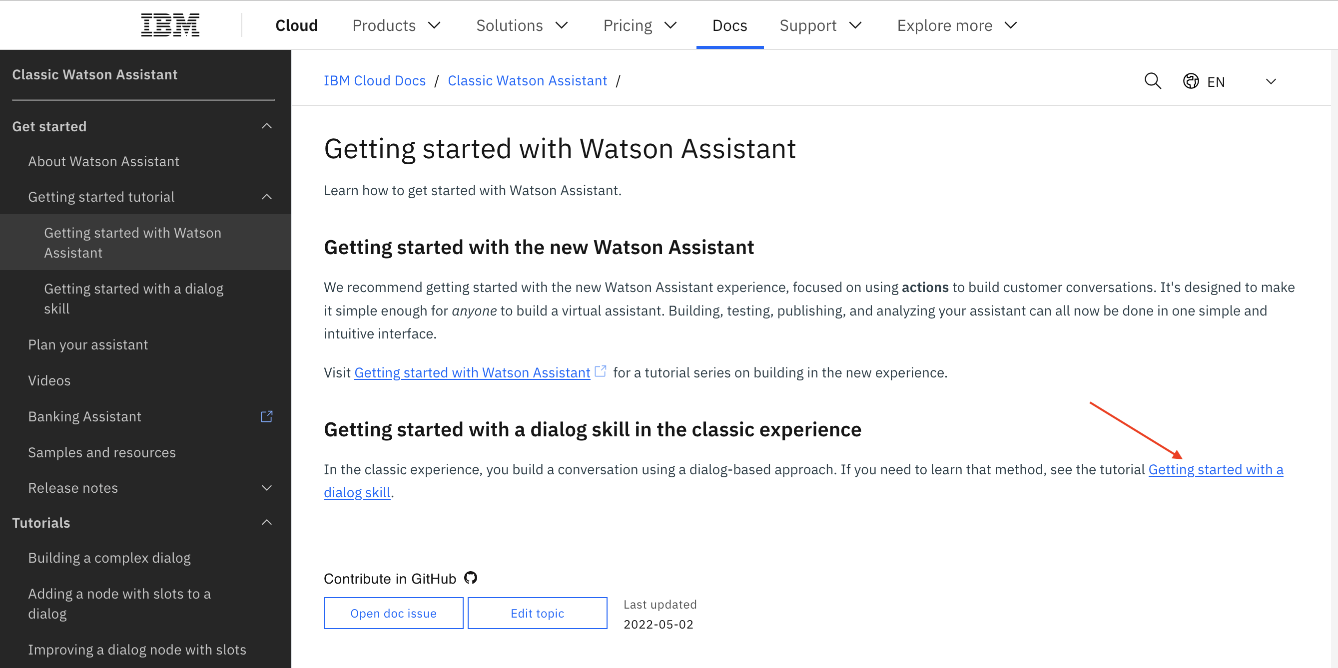

A new browser tab or window opens, and the Assistants page of Watson Assistant is displayed.

Complete all of the steps until the section of Next Steps (The steps therein are instructions for Lab 2).

# Lab 2: Create Watson Assistant Service

This documentation is for the **classic IBM Watson Assistant** experience. To see the documentation for the new Watson Assistant, please go [here](https://cloud.ibm.com/docs/watson-assistant).

In this tutorial, you will use the Watson Assistant service to create a dialog for an assistant that helps users with inquiries about a fictitious restaurant called *Truck Stop Gourmand*.

By the time you finish the tutorial, you will understand how to:

* Plan a dialog
* Define custom intents
* Add dialog nodes that can handle your intents
* Add entities to make your responses more specific
* Add a pattern entity, and use it in the dialog to find patterns in user input
* Set and reference context variables

This tutorial will take approximately 2 to 3 hours to complete.

**Prerequisite**

Before you begin, complete the [Getting Started tutorial](https://cloud.ibm.com/docs/assistant?topic=assistant-getting-started).

You will use the dialog skill that you created and add nodes to the simple dialog that you built as part of the getting started exercise.

